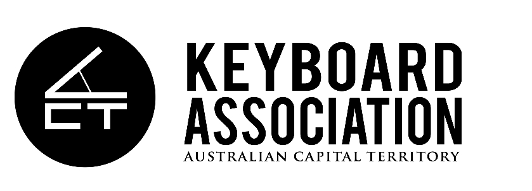

ACT Keyboard Association SPECIAL GENERAL MEETING 2018 (SGM)

Saturday September 8, 2018 at 5:00pm

DW Music, 301 Canberra Ave, Fyshwick ACT

AGENDA

Opening of Meeting

1. Adoption of changes to the ACTKA constitution

ACT Keyboard Association ANNUAL GENERAL MEETING (AGM)

Saturday September 8, 2018 (immediately following SGM)

DW Music, 301 Canberra Ave, Fyshwick ACT

AGENDA

Opening of Meeting

1. Apologies: Marie Cull

2. Confirmation of Minutes of previous Annual General Meeting

3. Presentation of President's Annual Report – Read on behalf of Marie by Vice-President Amber Harnisch

4. Adoption of Annual Report

5. Presentation of Treasurer’s Report - Glennyss Leyne

6. Election of Committee

- Nominations received

President – Marie Cull
Vice-Presidents – Giselle Roberts, Amber Harnisch
Secretary – Rebecca Simon
Treasurer – Glennyss Leyne
Committee members: Emily Leong and Veera Lehtimäki

- Nominations from the floor

3. Election by membership

7. Vote of thanks to outgoing Executives (Secretary) – Laura Baumeister

8. Notice/s of Motion - none this year

9. Questions & Comments

10. Thanks to the membership for their support – Amber Harnisch

Close

